This Document highlight how to commit a file to master branch in group github repository.

1. Create account in github.
2. I or theshan can invite members based on github username or email.
3. You will receive an invitation like below to the mail used to create the github account.

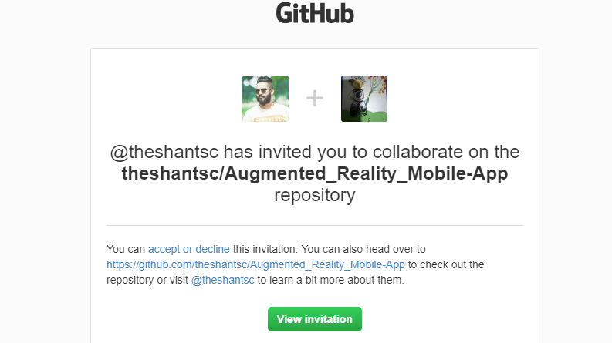

1. Accept the invitation>> Allow in next step too.
2. The remaining sections can be done by both commandline in your machine and source tree (GUI client for git ).
3. You have to install git in your machine (<https://git-scm.com/downloads>).
4. Then download SouceTree (<https://www.sourcetreeapp.com/>).
5. After install it you might have to connect it bitbucket account as indicate in the link.( <https://confluence.atlassian.com/get-started-with-sourcetree/connect-your-bitbucket-or-github-account-847359096.html>)
6. Go to SouceTree File >> Clone. 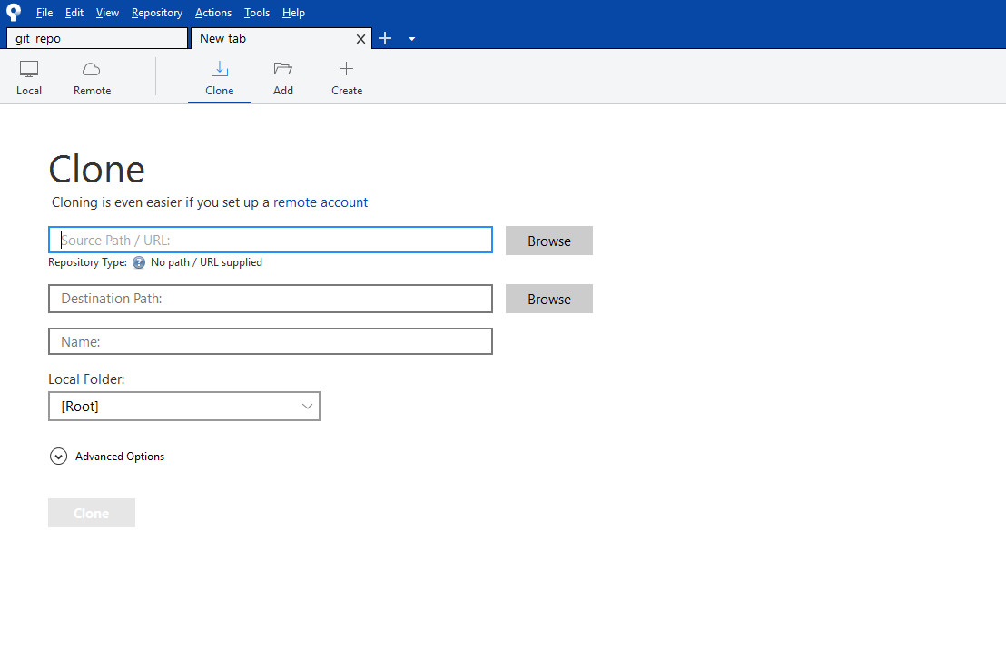
7. Provide the below
   1. URL : https://github.com/theshantsc/Augmented_Reality_Mobile-App.git
   2. Destination Path should be any folder in your local drive
   3. Then click on clone or ok button below.
8. If all the things go well you will see the below content in the folder you given. 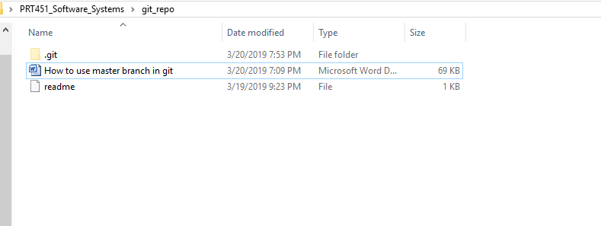
9. Create a text file with your name in that folder.
10. Go to source tree >> branches >> master
11. Select uncommitted changes and then click on push button.

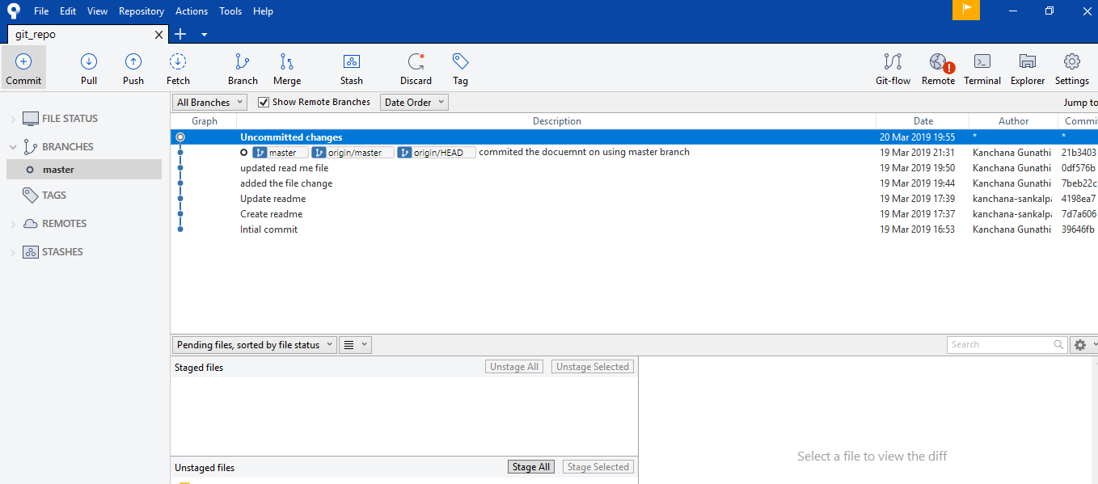

@Software Chasers